Proposal for Optimization via LLM AI Task Management

Preamble

* **Proposal ID:** [Unique Identifier]
* **Author(s):** V Dube
* **Submitted On:** [Submission Date]
* **Status:** [Draft/~~Review/Approved/Implemented~~]

Abstract

This proposal outlines a system leveraging Large Language Models (LLMs) to optimize task management within JIRA. The system aims to enhance user interaction by providing accurate and contextually relevant answers, improving task allocation and skill utilization.

Motivation

The proposal addresses the complexity of analyzing team tasks due to large volumes of related JIRA data. It aims to improve efficiency in task allocation and skill utilization by integrating LLMs, aligning with the company's goals of optimizing performance and resource management.

Benefits

Here are a few key benefits identified during the analysis and prototyping of the proposed solution identified.

1. Optimize task management and skill utilization within JIRA using Large Language Models (LLMs):
   1. Improve efficiency in task allocation by matching tasks with team members' skills and availability.
   2. Enhance analysis of team tasks and performance by leveraging the large amounts of related JIRA data.
2. Implement an AI-powered knowledge base system integrated with Slack:
   1. Create a system that can answer user queries by retrieving relevant information from JIRA, past Slack conversations, and other knowledge sources.
   2. Provide accurate and contextually relevant responses to improve user interaction and productivity.
3. Enhance decision-making and collaboration:
   1. Offer data-driven insights and predictive analytics to help project managers make informed decisions.
   2. Facilitate real-time collaboration and knowledge sharing across teams.
4. Improve efficiency and productivity:
   1. Automate routine tasks to free up team members for more strategic activities.
   2. Reduce time spent searching for information by providing quick access to relevant data.
5. Ensure data privacy and security:
   1. Implement measures to safeguard sensitive information, especially considering the integration with communication platforms like Slack.
6. Create a scalable and adaptable solution:
   1. Design a system that can handle large volumes of data and scale with the organization's needs.
   2. Continuously improve the system based on user feedback and interactions.
7. Enhance user satisfaction and engagement:
   1. Provide a user-friendly interface through Slack integration for easy interaction with the knowledge base.
   2. Offer personalized responses based on user history and context.
8. Support various project management activities:
   1. Assist with sprint planning, bug tracking, feature request management, and code review workflows.
   2. Help manage the CI/CD pipeline and development team workload.

Other Benefit summary…

1. Improved task allocation and skill utilization within JIRA.
2. Enhanced efficiency and productivity in team management.
3. Better user interaction through accurate and contextually relevant responses.
4. Real-Time Collaboration and Knowledge sharing
5. Proactive Assistance and Task Management
6. Scalable Knowledge Movement
7. Improved Decision-Making through Predictive Analytics
8. Enhanced Accountability and Auditability
9. Minimized Repetitive Queries
10. Centralized Access to Task and Communication Data
11. Personalized Learning and Training Support
12. Feedback-Driven Continuous Improvement
13. Reduced Cognitive Load on Project Managers
14. Cross-Team Knowledge Transparency
15. Real-Time Feedback on System Performance

**1. Data-Driven Insights**

Data-driven insights are a crucial component of leveraging AI to enhance decision-making and operational efficiency within an organization. By utilizing AI technologies, particularly Large Language Models (LLMs), the proposal aims to transform raw data into actionable insights that drive strategic improvements. Here are some detailed insights that can be derived from the proposed system

**Insight 1:** Enhanced Data Retrieval and Analysis **- Objective:** The system facilitates the retrieval of valuable data from JIRA, enabling more effective analysis of team tasks and performance.

**- Benefit:** By using semantic retrieval techniques, the system can quickly and accurately locate relevant data, reducing the time and effort required for manual data analysis. This allows project managers to make informed decisions based on comprehensive data insights, improving task allocation and resource management.

**Insight 2:** Predictive Analytics for Task Management **- Objective:** Leverage historical data and AI-driven predictive analytics to forecast future task requirements and team performance.

**- Benefit:** Predictive analytics can identify trends and patterns in task management, allowing teams to anticipate workload fluctuations and adjust resources accordingly. This proactive approach helps in optimizing team efficiency and ensuring that tasks are aligned with team members' skills and availability.

**Insight 3:** Personalized User Interaction **- Objective:** Use AI to tailor responses and recommendations based on individual user queries and historical interactions.

**- Benefit:** By personalizing interactions, the system enhances user satisfaction and engagement. Users receive contextually relevant information, which improves the overall experience and helps in resolving queries more effectively.

**Insight 4:** Continuous Improvement through Feedback Loops **- Objective:** Implement feedback mechanisms to refine AI models and improve the accuracy of insights over time.

**- Benefit:** By continuously learning from user interactions and feedback, the system can adapt and improve its performance. This iterative process ensures that the AI models remain relevant and effective in providing insights that align with evolving business needs.

**2. BAU Insights**

These insights highlight the transformative impact of integrating AI-driven analytics into task management systems, offering substantial improvements in efficiency, decision-making, and user satisfaction.

**Data-Driven Insight 1:** Enables valuable data retrieval from JIRA, enhancing decision-making and task management.

**Data-Driven Insight 2:** By leveraging LLMs, the system can provide insights into team performance and optimize resource allocation.

##### Others

##### 1. Enhanced Contextual Understanding:

- Benefit: The use of a vector database combined with an LLM allows the system to maintain and retrieve complex contextual information. This leads to more accurate and nuanced responses, as the system can understand and relate to the context of user queries beyond simple keyword matching.

- Impact: This improves the relevance of task recommendations and responses, ensuring that team members receive information that is directly applicable to their current needs and past interactions.

##### 2. Scalability in Information Retrieval:

- Benefit: Vector databases like ChromaDB are designed to handle large-scale data efficiently. As your organization grows and the amount of data in JIRA increases, the system will scale seamlessly, maintaining quick and accurate data retrieval.

- Impact: This ensures consistent performance and reliability of the task management system, even as the complexity and volume of data increase.

##### 3. Improved Decision-Making through Predictive Analytics:

- Benefit: Leveraging vector embeddings and LLM-driven insights allows the system to not only respond to current queries but also predict future trends, task requirements, and potential bottlenecks based on historical data.

- Impact: Project managers can make more informed decisions proactively, optimizing resource allocation and planning, and potentially avoiding issues before they arise.

##### 4. Increased User Satisfaction and Engagement:

- Benefit: The system’s ability to personalize interactions based on previous user data (stored in the vector database) enhances user satisfaction by providing more tailored and relevant responses.

- Impact: Higher engagement levels from users lead to more efficient workflows and greater adoption of the system across teams, contributing to overall productivity.

##### 5. Reduction in Redundant Tasks and Information Overload:

- Benefit: By using a vector database to manage and retrieve relevant data, the system minimizes the presentation of redundant information. Users receive concise, relevant insights without being overwhelmed by unnecessary details.

- Impact: This reduction in information overload leads to clearer decision-making processes and reduces the time spent sifting through irrelevant data.

##### 6. Support for Continuous Learning and Adaptation:

- Benefit: The system’s architecture, particularly the feedback loops in AI models, supports continuous learning. The more it is used, the more accurate and contextually aware it becomes, adapting to the evolving needs of the team and project requirements.

- Impact: Continuous improvement in the system’s recommendations and insights enhances long-term efficiency and ensures that the technology remains relevant and effective over time.

##### 7. Enhanced Data Privacy and Security:

- Benefit: By integrating advanced encryption and access controls within the vector database, the system ensures that sensitive task-related data and user interactions are protected from unauthorized access.

- Impact: This builds trust among users and stakeholders, ensuring compliance with data privacy regulations and protecting the organization’s intellectual property.

Solution Outline Diagram

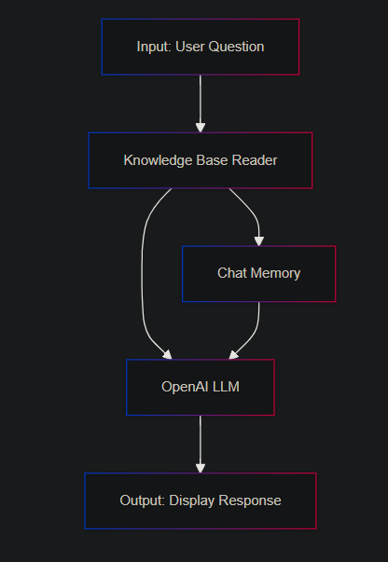

##### *Note* = All code snippets are for direction and functional representation purposes only. These will need to be reviewed and ratified with relevant technical SMEs before application in OB systems.

##### 1. Input: User Question (Slack Integration)

- User Action: The user interacts with the system by asking a question through Slack. For example, a project manager may ask, "What's the status of the current tasks in Project X?" or "Who is available to handle a new task?"

- System Action: The query is captured by a custom Slack command (e.g., `/askkb`) or through direct messages to the Slack bot, and it is forwarded to the Knowledge Base Reader for processing.

##### 2. Knowledge Base Reader (Integrating JIRA and Knowledge Sources)

- Function: The Knowledge Base Reader is responsible for fetching relevant information from various sources such as JIRA (task assignments, statuses, etc.) and previously stored knowledge in the system.

- How It Works:

- The system uses the query to retrieve relevant structured data from JIRA (for tasks and projects) and unstructured data from past Slack conversations.

- It semantically understands what the user is asking and matches that with the information available.

- Integration: In this case, Slack serves as both an input (user query) and as a source of knowledge for the Knowledge Base Reader to draw from (past conversations, discussions, and decisions).

##### 3. Chat Memory (Context Awareness)

- Function: Chat Memory stores the history of user interactions, including previous queries and responses. This allows the system to maintain context over time and provide more accurate and contextually aware responses.

- How It Works:

- When a user asks a question, Chat Memory is checked for any relevant past interactions, enabling the system to generate responses that are consistent with previous exchanges.

- This is especially useful for follow-up questions or ongoing project discussions where maintaining context is crucial.

- Example: If the user previously asked about a project status, Chat Memory might retain that context, allowing the system to automatically reference it when the user asks about task dependencies later.

##### 4. Open Source LLM (Processing the Query)

- Function: An Open Source LLM (such as GPT-Neo, GPT-J, or similar models) processes the enriched query, combining the retrieved data from the Knowledge Base Reader and contextual information from Chat Memory.

- How It Works:

- The LLM takes the user’s query, historical context, and any relevant data (from Slack, JIRA, and the Knowledge Base) to generate a human-like response.

- Personalization: The system provides a response tailored to the user’s past interactions and the current query.

- Natural Language Processing (NLP): The LLM helps to understand the semantics of the question and generate coherent, contextually relevant responses.

##### 5. Output: Display Response (Slack Output)

- Function: The system sends the generated response back to the user through Slack.

- How It Works:

- The user receives the response directly in Slack, where it is formatted in an easy-to-read manner. The response can include information such as task status, recommendations, resource availability, or links to related JIRA tickets.

- If necessary, the response can include attachments or links to more detailed documents stored in the Knowledge Base or references to JIRA tasks and project dashboards.

##### In Summary (Solution Overview):

1. Slack as an Interface: The user inputs their query directly into Slack. The system uses this platform as both an input and output mechanism, ensuring seamless integration with daily communication workflows.

2. Knowledge Base Reader and JIRA: The Knowledge Base Reader searches JIRA and Slack archives for relevant information, pulling data that matches the user's query.

3. Context Awareness (Chat Memory): The system maintains the history of interactions, allowing for contextually aware conversations and smarter follow-up responses.

4. Open Source LLM: The LLM processes the enriched query to generate a natural language response that is both informative and contextually appropriate.

5. Real-Time Response in Slack: The final output is delivered back to the user in Slack, ensuring quick and easy access to critical project or task information without leaving the communication tool.

Advantages:

- Task Management and Allocation: With JIRA integration, task-related queries can be quickly resolved within Slack, enhancing team productivity.

- Collaborative Knowledge Sharing: By leveraging both JIRA data and Slack conversations, the system promotes a transparent and collaborative work environment.

- Proactive Notifications and Updates: The system can trigger proactive alerts or suggestions, helping project managers keep track of deadlines, task assignments, and potential bottlenecks.

- Personalized User Interactions: Chat Memory allows the system to offer personalized responses based on prior interactions, making follow-up questions more accurate and contextually relevant.

This solution brings together AI-driven insights, integrated task management, and real-time communication in a user-friendly manner this will be best achieved via Slack, providing a robust platform for task and knowledge management within teams

##### Slack as I/O see appendix 2 for Slack detailed setup guide

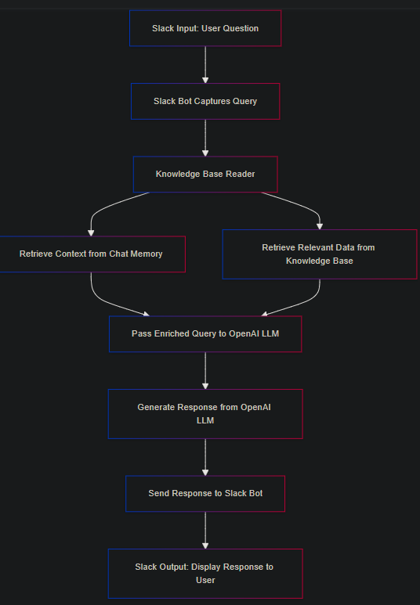

##### Explanation of Flow:

1. Slack Input: User inputs a question through Slack (via a custom command or message).

2. Slack Bot: The bot captures the query and sends it to the Knowledge Base Reader.

3. Knowledge Base Reader: This component processes the query and retrieves relevant data from the Knowledge Base.

4. Chat Memory: It looks up historical context related to the query from previous conversations.

5. Open Source LLM: The enriched query (with context from Chat Memory and data from the Knowledge Base) is sent to the Open Source LLM for processing.

6. Response Generation: The Open Source LLM generates a response.

7. Slack Bot: The response is sent back through the Slack bot.

8. Slack Output: The user receives the response directly in Slack.

This flow provides a clear path for using Slack as both the input and output interface for querying the Knowledge Base system, seamlessly integrating it into team communications.

##### 1. Input: User Question (via Slack)

- Slack Integration:

- Users can input their questions directly through Slack using custom commands (e.g., `/askkb [query]`).

- A Slack bot listens for these commands and forwards the user’s query to the Knowledge Base Reader. - Slack API:

- You can use the Slack Events API and slash commands to capture user inputs and send them to the Knowledge Base system.

- Custom Bot: A bot created in Slack handles all input, processes queries, and sends them for further action.

##### 2. Knowledge Base Reader and Chat Memory:

- Once the question from Slack is received, it flows through the existing system exactly as described in your diagram. The Knowledge Base Reader pulls relevant data and retrieves historical context from Chat Memory if needed.

- This intermediate processing remains the same, meaning the system can search through previous Slack conversations stored in the Chat Memory, as well as the knowledge it retrieves from the Knowledge Base.

##### 3. Open Source LLM Processing:

- The query, enriched with historical context from the Chat Memory and additional data from the Knowledge Base Reader, is passed to the Open Source LLM for final processing.

- The LLM generates a response that is contextually aware and relevant to the user’s query.

##### 4. Output: Display Response (via Slack)

- Response Delivery via Slack:

- The response generated by the Open Source LLM is sent back to the user through the same Slack bot that handled the input.

- Chat.postMessage API: Slack’s chat.postMessage method can be used to send the generated response back to the channel or directly to the user who initiated the query.

- Customization:

- The response can be customized in various formats—simple text, attachments, or rich formatted messages with links to further resources (e.g., related JIRA tasks or threads from past Slack conversations).

##### Summary of Slack Integration in Your Solution:

1. Slack as Input: Users input queries using custom Slack commands or a bot, which forwards the queries to the Knowledge Base.

2. Slack as Output: Once the query is processed through the system (Knowledge Base Reader, Chat Memory, LLM), the response is sent back to the user via Slack, creating a seamless experience.

##### Slack API Tools to Implement:

- Slash Commands: Create custom commands like `/askkb [query]` for user input.

- Slack Events API: Capture events when users send messages to the bot.

- Chat.postMessage: Send LLM responses back to users or channels.

##### Component Detail

##### 1. Input Module

Function: The Input Module is responsible for capturing user questions and queries. It serves as the entry point for user interaction with the system.

Details:

- Field Name: `User_Query`cc

- Type: `Text`

Data Flow: Once a user inputs a question, the Input Module sends the question to both the Knowledge Base Reader and the Chat Memory components. This dual-routing ensures that the query is processed with the most relevant and contextual information.

Key Considerations:

User Experience: The Input Module must be intuitive and responsive, allowing users to input their questions easily and receive confirmation that their query has been successfully submitted.

Validation: The system should validate user input to ensure it's not empty and is formatted correctly, providing feedback if necessary.

##### 2. Knowledge Base Reader

Function: The Knowledge Base Reader queries the vector store for relevant information based on the user's question. It is a critical component for semantic retrieval, helping the system find the most relevant data to respond to user queries.

Details:

- Uses semantic-based retrieval.

Data Flow:

- Sends queries to the vector store.

- Retrieves results and sends context to the Open Source LLM.

##### 3. Chat Memory

Function: The Chat Memory stores and provides historical context for the system. It helps maintain the continuity of conversations, allowing the system to refer back to previous interactions when generating responses.

Data Flow: Sends historical data to the Open Source LLM.

##### 4. Open Source LLM

Function: The Open Source LLM (Large Language Model) processes user questions using both the current input and historical context from the Chat Memory. It generates the final response that is then displayed to the user.

Details:

- Model: This could involve using open-source models such as GPT-Neo, GPT-J, or BLOOM.

System Prompt: Guides the LLM to use context effectively, ensuring the generated responses are relevant and accurate.

##### 5. Output Module

Function: Displays the generated response.

- Details:

- Field Name: `output1`

- Type: `Text`

Data Flow: Receives and presents the response to the user.

USE CASE DIAGRAMS

###### 1. Sprint Planning and Management

**Description**: Effectively manage sprint planning by organizing user stories, tasks, and bugs. Assign tasks to team members, track progress throughout the sprint, and adjust priorities as needed.

**Key Features**: Task boards, Gantt charts, sprint backlogs, progress tracking.

**Outcome**: Improved sprint execution with clear visibility into task assignments, ongoing progress, and the ability to respond quickly to changes in scope or priorities.

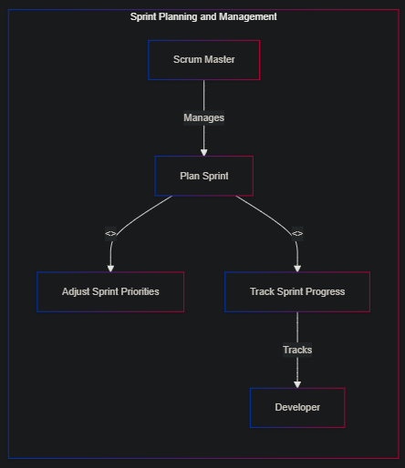

###### 2. Task Allocation Based on Skill Set

**Description**: Optimize resource utilization by automatically assigning tasks to developers based on their skill sets and availability. Analyze task requirements and match them with the most suitable team members.

**Key Features**: Skill matrices, task matching algorithms, workload balancing.

**Outcome**: Efficient use of team resources, ensuring that tasks are handled by the bestsuited developers, leading to faster and higherquality output.

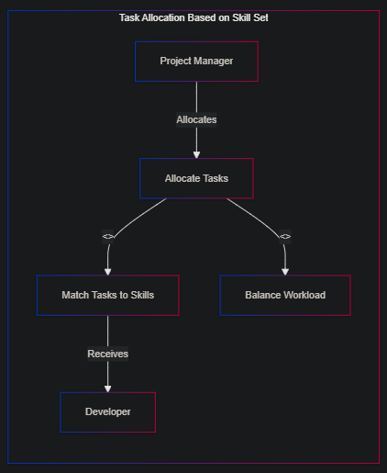

###### 3. Progress Tracking and Reporting

**Description**: Continuously monitor the progress of development tasks and milestones. Generate and share progress reports with stakeholders to keep everyone informed and aligned.

**Key Features**: Milestone tracking, real-time dashboards, automated reporting.

**Outcome**: Enhanced transparency and communication across teams and stakeholders, allowing for proactive management of timelines and resources.

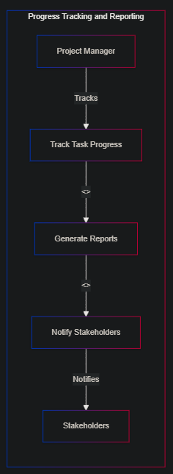

###### 4. Bug Tracking and Resolution

**Description**: Implement a system to capture, prioritize, and track bugs throughout the development process. Ensure that critical bugs are addressed promptly by setting up automated alerts and workflows.

**Key Features**: Bug tracking boards, priority tags, automated alerts.

**Outcome**: Faster bug resolution with clear tracking, leading to improved software quality and reduced production issues.

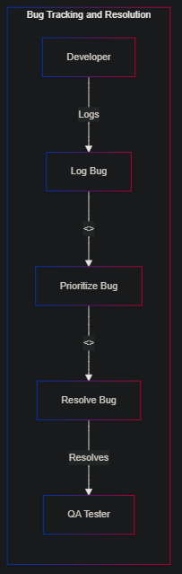

###### 5. Feature Request Management

**Description**: Manage feature requests from stakeholders by capturing them, prioritizing based on impact and feasibility, and tracking their development through to release.

**Key Features**: Request submission forms, prioritization frameworks, development tracking.

**Outcome**: Streamlined feature development process, ensuring that highimpact features are delivered efficiently and meet stakeholder expectations.

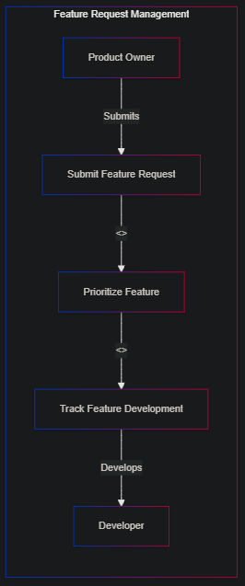

###### 6. Code Review Workflow Automation

**Description**: Automate the code review process by integrating with version control systems. Trigger notifications and task updates when code is ready for review, and track the review process to ensure timely feedback.

**Key Features**: Code review checklists, automated notifications, version control integration.

**Outcome**: Accelerated code review process, reducing bottlenecks and ensuring that quality checks are consistently applied before code is merged.

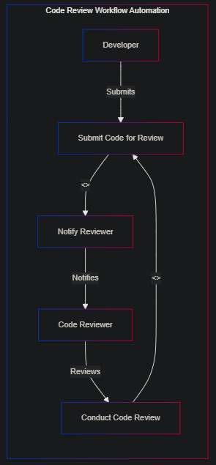

###### 7. Continuous Integration/Continuous Deployment (CI/CD) Pipeline Management

**Description**: Monitor and manage the CI/CD pipeline by tracking deployment status, managing rollbacks, and coordinating team responses to deployment issues.

**Key Features**: CI/CD pipeline dashboards, automated deployment tracking, rollback management.

**Outcome**: Improved coordination and visibility into the CI/CD process, reducing deployment risks and ensuring smooth, timely releases.

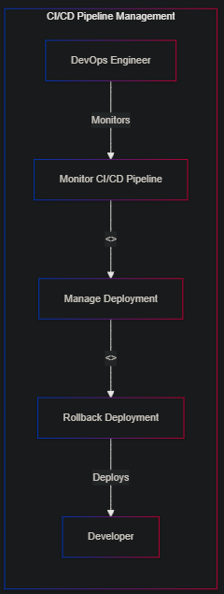

###### 8. Development Team Workload Management

**Description**: Monitor and manage the workload of development team members to ensure tasks are evenly distributed and prevent burnout. Adjust task assignments in realtime based on changing priorities or resource availability.

**Key Features**: Workload dashboards, realtime task reassignment, capacity planning tools.

**Outcome**: Balanced workload distribution, leading to sustained productivity and improved team morale.

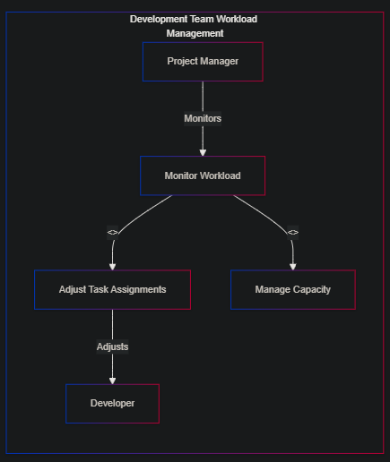

###### 9. Agile Retrospectives and Action Items Tracking

**Description**: Document and track action items from Agile retrospectives. Assign tasks to team members and monitor progress on implementing improvements identified during retrospectives.

**Key Features**: Retrospective boards, action item tracking, followup reminders.

**Outcome**: Continuous improvement in development practices, with a structured approach to implementing and tracking the outcomes of retrospectives.

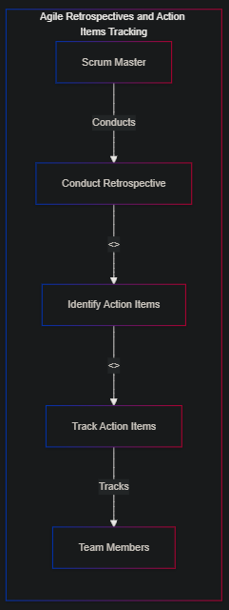

###### 10. Release Planning and Execution

**Description**: Plan and execute software releases by managing tasks, dependencies, and timelines. Track progress and ensure that all release criteria are met before going live.

**Key Features**: Release calendars, dependency tracking, readiness checklists.

**Outcome**: More predictable and controlled release processes, reducing the risk of delays or issues at launch and ensuring alignment across all stakeholders.

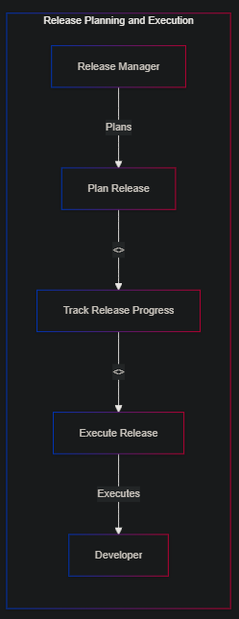

User Stories – Solution E2E

##### 1. User Story: Input Module

As a user, I want to input my question into the system so that I can receive relevant information and assistance.

Acceptance Criteria:

1. The system should allow users to input text-based questions in a designated field.

2. The input module must validate the input to ensure it is not empty before submission.

3. The system should confirm that the question has been successfully received and is being processed.

4. The input data should be routed correctly to both the Knowledge Base Reader and Chat Memory for further processing.

5. The user should receive feedback if the input fails to be captured or processed.

##### 2. User Story: Knowledge Base Reader

As a system administrator, I want the Knowledge Base Reader to query the vector store efficiently so that it can provide the most relevant context for user queries.

Acceptance Criteria:

1. The Knowledge Base Reader must query the vector store within a set response time (e.g., under 2 seconds).

2. The system should retrieve and prioritize the most relevant information from the vector store.

3. The retrieved data should be accurately passed to the Open Source LLM for further processing.

4. The system should log each query for auditing and troubleshooting purposes.

5. If the vector store fails to provide relevant results, the system should offer a fallback mechanism, such as querying an alternative database or notifying the user.

##### 3. User Story: Chat Memory

As a user, I want the system to remember my previous interactions so that it can provide contextually accurate responses.

##### Acceptance Criteria:

1. The system must store user interactions securely and associate them with the correct user session.

2. The Chat Memory should retrieve and provide relevant historical data to the OpenSource LLM when processing a new query.

3. The system should ensure that stored interactions are accessible only to the appropriate user or session.

4. The Chat Memory should have a mechanism for updating or deleting outdated or irrelevant historical data.

5. The system should provide the user with an option to clear or reset their chat history if desired.

##### 4. User Story: Open Source LLM Integration

As a developer, I want the Open Source LLM to process user questions using both current and historical data so that it can generate comprehensive and accurate responses.

Acceptance Criteria:

1. The Open Source LLM must generate responses within a defined time frame (e.g., under 5 seconds) after receiving input and context.

2. The model should use both current input and historical context from Chat Memory to form its response.

3. The system should ensure that the LLM-generated responses are contextually relevant and accurate based on the provided data.

4. The LLM should be regularly updated with the latest open-source models and fine-tuned to avoid outdated or biased responses.

5. The system should log LLM responses for continuous improvement and monitoring of accuracy.

##### 5. User Story: Output Module

As a user, I want to see the response clearly displayed so that I can easily understand the information provided.

##### Acceptance Criteria:

1. The system must display the LLM-generated response in a user-friendly format, ensuring readability and clarity.

2. The response should be presented promptly, without unnecessary delay after processing.

3. The output module should handle different response formats (e.g., text, links) and display them appropriately.

4. The system should offer a feedback mechanism for users to rate the helpfulness or accuracy of the response.

5. The output should be accessible across different devices and platforms, maintaining consistent formatting.

##### 6. User Story: LLM-Enhanced Task Management for JIRA

As a project manager, I want the LLM to help optimize task allocation and skill utilization within JIRA so that the team can work more efficiently.

##### Acceptance Criteria:

1. The LLM should analyze tasks within JIRA and suggest optimal task allocation based on team members' skills.

2. The system must integrate seamlessly with JIRA, requiring minimal manual intervention.

3. The LLM-generated task allocations should be reviewed and approved by a project manager before being finalized.

4. The system should provide analytics on how LLM-driven task allocation improves efficiency over time.

5. The LLM should be adaptable to different project types and complexities within JIRA.

User Stories – Slack Bot

The following are user stories for the Slack solution functioning as the input/output interface for querying the Knowledge Base and relevant acceptance criteria:

##### User Story 1: Slack Input Module

As a user, I want to input my questions through Slack so that I can easily query the Knowledge Base for relevant information.

Acceptance Criteria:

1. The system should allow users to input text-based queries using a Slack command (e.g., `/askkb`).

2. The bot should confirm the successful receipt of the query within Slack.

3. The input query should be forwarded to the Knowledge Base Reader and Chat Memory for processing.

4. If the bot fails to capture or process the input, a failure notification should be returned in Slack.

5. The system should validate that the query is not empty before processing.

##### User Story 2: Knowledge Base Query Processing

As a system administrator, I want the Knowledge Base Reader to process Slack queries efficiently so that the system can return relevant answers in a timely manner.

Acceptance Criteria:

1. The Knowledge Base Reader must respond to Slack queries within 2 seconds.

2. The system should retrieve the most contextually relevant data based on the user’s query.

3. The retrieved data should be processed and sent to the Open Source LLM for a comprehensive response.

4. The system must log every query for auditing and troubleshooting.

5. If the Knowledge Base cannot retrieve relevant information, the bot should notify the user and suggest alternate actions.

##### User Story 3: Chat Memory Integration

As a user, I want the system to remember my previous interactions from Slack so that the Knowledge Base provides accurate, context-aware responses to follow-up questions.

Acceptance Criteria:

1. The system must securely store previous user interactions within Chat Memory and associate them with the correct user.

2. When processing a new query, Chat Memory should retrieve relevant historical context and provide it to the Open Source LLM.

3. The system should allow users to clear or reset their conversation history if desired.

4. Only authorized users should have access to their own stored interaction data.

5. The system must periodically update or delete outdated or irrelevant historical data.

##### User Story 4: Response Generation via Open Source LLM

As a developer, I want the Open Source LLM to use both the current input and historical data from Slack to generate accurate and complete responses for users.

Acceptance Criteria:

1. The Open Source LLM must generate responses within 5 seconds after receiving the query.

2. The responses should leverage both current user input and relevant historical data retrieved from Chat Memory.

3. Responses must be contextually accurate and relevant based on the query and historical context.

4. The system should log LLM responses to ensure quality and accuracy.

5. The Open Source LLM should be regularly updated to avoid outdated or biased responses.

##### User Story 5: Slack Output Module

As a user, I want the response to be displayed clearly in Slack so that I can easily understand the information returned by the Knowledge Base.

1. The system should display responses from the Open Source LLM in a user-friendly format in Slack (e.g., rich text, attachments).

2. The response should appear promptly in Slack after processing the query.

3. The system should allow users to give feedback on the helpfulness of the response directly within Slack (e.g., thumbs up/down).

4. The response formatting should be consistent across different devices (desktop, mobile, web).

5. The output module should handle links and references to JIRA tasks, past Slack discussions, or other external sources appropriately.

##### User Story 6: Feedback Mechanism in Slack

As a user, I want to provide feedback on the bot's responses so that the system can improve over time.

Acceptance Criteria:

1. The Slack bot should prompt users to rate the response after each query (e.g., with a rating scale or thumbs-up/thumbs-down options).

2. Feedback should be stored for later analysis and improvement of the LLM.

3. The system should act on user feedback to improve the accuracy and relevance of future responses.

4. Users should have an option to leave comments along with their feedback to provide additional context.

##### User Story 7: Task Allocation via Slack Queries

As a project manager, I want to use Slack to query the Knowledge Base for optimal task allocation based on team members' skills and availability.

Acceptance Criteria:

1. The Slack bot should allow the project manager to query for task allocation insights (e.g., "Who should handle this bug fix?").

2. The system should provide suggestions for optimal task assignment based on team members' skills and current workload.

3. Suggestions must be generated and returned to Slack within 5 seconds of the query.

4. The system should also allow task assignments to be approved or modified directly within Slack.

5. The task allocation insights should integrate seamlessly with JIRA, requiring minimal manual intervention.

##### Points of Note

These user stories and acceptance criteria outline how users interact with Slack to query and manage information from the Knowledge Base and how the system processes, responds to, and improves based on those interactions. They ensure the integration works effectively for endusers, administrators, and developers alike.

Technical Specification

**Architecture Overview**

The system includes an Input Module, Knowledge Base Reader, Chat Memory, Open Source LLM, and Output Module. The technical architecture of this OBIP will revolve largely around three components.

* The Llama Framework to host and serve LLM's
* An API facade to sit in front of the Llama endpoints
* A Vector DB to support Retrieval Augmentation (RAG)
* An inference AI Bot (OpenBot)

**Technology Choices**

The specific technologies, platforms and frameworks proposed are:

* The Llama Framework/Host will be served using docker containers in the Azure Cloud
* Python to build the fast API facade to sit in front of the Llama end-points
* Chroma DB Vector Database(s) for k-nearest neighbor search storage to facilitate Retrieval Augmentation (RAG)
* A bot UI built using the Google Flutter Framework. The bot will compile/target to all mobile platforms, Windows and Mac Desktop and Web/Browser.
* All hosting to be done inside Azure Container Instances (ACI)

**Integration with Existing Systems**

Seamlessly integrates with JIRA and Slack (APIs) to enhance task management.

Artificial Intelligence Considerations

**Regulatory Compliance**

1. Adherence to Legal Standards:

The system ensures strict compliance with data protection regulations such as GDPR (General Data Protection Regulation) and CCPA (California Consumer Privacy Act). These regulations dictate how user data must be collected, stored, and processed to protect individual rights and ensure transparency.

The system's AI algorithms and data processing workflows must adhere to these legal standards, ensuring that user consent is obtained, data is anonymized when necessary, and retention policies are followed.

2. Monitoring and Updates:

Regular audits will be conducted to ensure ongoing compliance with any evolving legal standards and regulations. The system should have mechanisms to update and notify users of any changes in data policies or AI regulations that may affect their privacy.

**Data Privacy and Security Considerations**

##### Encryption and Access Controls:

End-to-End Encryption: All data in transit (such as user queries and Slack interactions) and at rest (stored responses, user history) must be encrypted using industry-standard protocols (e.g., AES-256 for data storage, TLS 1.2/1.3 for data transmission). The Fernet symmetric encryption scheme has been applied conforming to the AES-256 base standard.

##### Access Control

Implement role-based access control (RBAC), ensuring that only authorized personnel or users can access sensitive information. For instance, only the data owner (user) or designated roles such as system administrators should be able to access specific historical chat data or personal information.

##### DP & S Consideration 1: Data Minimization and Anonymization:

Minimization: The system will only collect data necessary for its functioning, avoiding the collection of unnecessary user details.

Anonymization: Where feasible, the system will anonymize user data, ensuring that personally identifiable information (PII) is stripped from stored datasets. For example, user queries and interactions can be logged without associating them with specific user identities unless required for auditing or user personalization.

##### DP & S Consideration 2: Secure Data Storage:

All user data, including historical chat data, personal interactions, and task-related information, will be securely stored in a centralized location protected by both physical and digital safeguards. This includes database encryption, firewalls, and regular security patch updates.

##### DP & S Consideration 3: Incident Response Plan:

A comprehensive Incident Response Plan (IRP) will be implemented to manage any potential data breaches or security incidents. This plan will outline the steps to contain the breach, notify affected users, and mitigate any further risks.

Risks and Mitigations

1. Risk 1: Data Breach or Unauthorized Access:

- Mitigation: Implement multi-factor authentication (MFA) and encryption for all access points. Regularly audit access logs and use intrusion detection systems (IDS) to monitor any unusual activity.

2. Risk 2: AI Bias or Inaccurate Predictions:

- Mitigation: Regularly audit and test the AI models to ensure that they are unbiased and provide accurate predictions. This can be achieved through ongoing training using diverse datasets and periodic evaluations of the model outputs to detect any potential biases.

3. Risk 3: Non-Compliance with Evolving Regulations:

- Mitigation: Establish a dedicated legal and compliance team that stays updated on new regulations and updates the system accordingly. Automatic updates to privacy policies and data retention practices should be implemented to remain compliant.

4. Risk 4: User Data Leakage through Third-Party Integrations:

- Mitigation: Ensure that all third-party integrations (e.g., Slack and JIRA) adhere to the same strict data security and privacy protocols. Perform regular security assessments on third-party services and restrict data sharing to necessary information only.

Implementation Plan

1. Phase 1: Planning and Requirements Gathering (1-2 Weeks)

- Identify stakeholders and gather specific system requirements.

- Define user stories, personas, and use cases for the Slack integration and Knowledge Base system.

- Conduct a legal risk assessment to ensure regulatory compliance from the start.

2. Phase 2: System Design (2-3 Weeks)

- Design the system architecture, including the Knowledge Base, Slack integration, and security infrastructure.

- Create detailed design documents for how data will be processed, stored, and secured.

- Define integration points for Slack and JIRA APIs.

3. Phase 3: Development (6-8 Weeks)

- Develop the backend (Knowledge Base, LLM, Chat Memory) and connect to Slack using the Slack API.

- Implement role-based access control and encryption protocols.

- Develop Slack commands, notifications, and real-time query handling.

- Conduct testing for data privacy, query accuracy, and response times.

4. Phase 4: Testing and Quality Assurance (2-3 Weeks)

- Conduct extensive testing for security vulnerabilities, performance, and scalability.

- Test the AI model to ensure it returns accurate, unbiased, and contextually relevant responses.

- Test the Slack integration for smooth user experience and seamless interaction.

5. Phase 5: Deployment and User Training (1-2 Weeks)

- Deploy the system on a secure, scalable infrastructure (e.g., AWS, GCP).

- Provide user training sessions on how to interact with the Knowledge Base via Slack and how to provide feedback on responses.

- Ensure compliance documentation and incident response plans are in place.

6. Phase 6: Ongoing Monitoring and Maintenance (Continuous)

- Monitor system performance, security, and compliance.

- Continuously update the AI models and Knowledge Base content based on user feedback and evolving regulatory requirements.

- Conduct periodic audits and security reviews.

##### NOTES!

~~VD = Account for Notes being retrieved from JIRA as being utilized for both Semantic Search as well as Knowledgebase for LLM. Vectorization should leverage “\askg” user requests via the JIRA noted related inputs in the LLM for each query should there be a vector correlation.~~

~~Don’t forget to add these additional commands to the Slack API slash commands.~~

~~# Register handlers for various Slack commands~~

~~slack_bot.app.command("/allocate_task")(slack_bot.handlers.handle_task_allocation)~~

~~slack_bot.app.command("/workload_report")(slack_bot.handlers.handle_workload_report)~~

~~slack_bot.app.command("/reallocate_tasks")(slack_bot.handlers.handle_task_reallocation)~~

~~slack_bot.app.command("/kb_add")(slack_bot.handlers.handle_kb_add)~~

~~slack_bot.app.command("/kb_search")(slack_bot.handlers.handle_kb_search)~~

~~slack_bot.app.command("/kb_update")(slack_bot.handlers.handle_kb_update)~~

~~slack_bot.app.command("/kb_delete")(slack_bot.handlers.handle_kb_delete)~~

~~slack_bot.app.command("/kb_info")(slack_bot.handlers.handle_kb_info)~~

~~# New commands for LLM functionalities~~

~~slack_bot.app.command("/summarize")(slack_bot.handlers.handle_summarize)~~

~~slack_bot.app.command("/semantic_search")(slack_bot.handlers.handle_semantic_search)~~

**Build Video DEMO!!**

Resources Required

1. Personnel:

- AI Engineer: Responsible for implementing and refining AI models for response generation.

- Backend Developer: For integrating APIs (Slack, JIRA) and building the Knowledge Base infrastructure.

- Data Privacy Officer (DPO): To ensure compliance with GDPR, CCPA, and other data privacy regulations.

- DevOps Engineer: To manage infrastructure, deployment, and ensure scalability and security.

- UX/UI Designer: For designing an intuitive Slack-based user interface and ensuring smooth interactions.

2. Technology:

- Slack API: For user interactions and notifications.

- Vector Database: (e.g., Pinecone, Milvus) to store and retrieve query data efficiently.

- Cloud Infrastructure: (e.g., AWS, GCP) for hosting the system securely with automatic scaling and backups.

- Open Source LLM: For natural language processing and query response generation.

- Encryption Tools: For data protection, such as AES-256 and TLS 1.3.

3. Budget:

- Cloud Hosting: Estimated monthly cost for infrastructure hosting, data storage, and processing resources.

- Licensing: For any proprietary tools or software required for the project.

- Personnel: Salaries for development, AI, and compliance team members.

- Training: Budget for user training sessions and materials.

Concluding Remarks

The integration of a robust, AI-powered Knowledge Base with Slack I/O capabilities offers immense value to organizations by improving task management, collaboration, and decision-making. This system not only streamlines internal processes but also ensures compliance with critical data privacy and security regulations. By leveraging user interaction data through Slack and refining responses via open-source AI models, this solution evolves into a dynamic, intelligent assistant that drives efficiency and productivity across teams. Given the outlined resources and implementation steps, this proposal is both feasible and highly impactful for improving organizational knowledge sharing and operational workflows.

Appendices

**Appendix 1**

##### Risk Factors:

* Model Bias: LLM may inherit or amplify biases from training data.
* Over Reliance on LLM: Risk of reduced critical thinking and skill atrophy.
* Data Misinterpretation: LLM may misinterpret data, leading to incorrect decisions.
* System Vulnerabilities: Potential for cyberattacks or security breaches.
* Scalability Issues: Challenges in scaling without compromising performance.
* Legal and Ethical Considerations: Risk of legal issues from AI misuse.
* Ownership of Fine-Tuned Model: While you don't own the base architecture, you generally own the specific weights and adaptations resulting from your fine-tuning process. This gives you more control over how the model is used and distributed.

**Types of Data**

##### Identification of Data Involved

##### Personal Information

- Is personal information involved?: Yes, the proposal potentially involves the handling of personal information.

- Relevant Data: Personal data such as user profiles, names, email addresses, Slack message content, and potentially task assignments within JIRA (which could be linked to individuals).

- Data Sources:

- Slack: Collects usernames, messages, activity logs, and interaction history.

- JIRA: Stores information about individuals' task assignments, project roles, and timelines.

- Knowledge Base: May contain records of user interactions and feedback.

##### OB Proprietary, Confidential, or Commercial-in-Confidence Data

- Is proprietary or confidential information involved?: Yes, the proposal may involve sensitive or proprietary data.

- Relevant Data:

- Internal communications: Slack messages, project management data in JIRA, and Knowledge Base discussions could include sensitive company information, trade secrets, or confidential project details.

- Data Sources:

- Internal Slack channels and JIRA could contain proprietary strategies, product development details, financial information, or commercial agreements.

##### Public and/or Proprietary Datasets

- Are public or proprietary datasets involved?:

- Public datasets may not be directly involved unless external data sources are integrated into the Knowledge Base for training or reference.

- Proprietary datasets such as internal documentation, previous project logs, and decision-making histories could be used as part of the Knowledge Base.

**Use of Data**

##### How and Why the Data Will Be Used

- User Queries: Slack conversations and JIRA task data will be used to answer user queries, provide task updates, and recommend actions based on project history.

- Knowledge Base: Internal project data and Slack conversations will be stored and indexed for future retrieval.

- Chat Memory: Previous conversations will be used to provide contextually aware responses and personalized interactions.

##### Where the data will be stored

- Storage Locations: Data will be stored in secure cloud environments (e.g., vector databases for semantic search, cloud-based file storage for documents).

- Data Types: Slack messages, JIRA task data, and Knowledge Base interactions will likely be stored in cloud databases or vector storage for retrieval and processing.

##### **Disclosure of Data**

##### Internal Disclosure

- Internal Use: Data (such as Slack messages, project timelines, or Knowledge Base entries) will be disclosed internally among team members. For instance, a project manager may retrieve details of past Slack discussions to manage tasks or allocate resources.

- Training Data: If the AI system requires training, internal data (Slack conversations, JIRA tasks) may be used to train the models to understand project management flows, user behavior, and queries.

##### External Disclosure

- External Use: There may be no external disclosure of data unless external data sources or partners are involved in providing insights or if third-party services (e.g., cloud services or AI models) are used.

##### Automated Decision Making

- Does the system perform automated decision making?: Yes, the system could involve some degree of automated decision-making, particularly in task recommendations, project prioritization, and workflow automation.

- Example: The system may automatically suggest task reassignments, predict bottlenecks, or recommend deadlines based on past interactions and current workload data.

##### Evaluation or Scoring (Profiling or Predicting) of Individuals

##### Profiling or Predicting Individuals

- Does the system profile individuals?: The system may indirectly profile users based on their Slack activity, roles, and interaction history.

- Example: A user’s past activity could influence task recommendations, resource allocation, or project management decisions, but this is likely focused on improving team productivity rather than individual profiling for scoring or evaluation.

##### Systematic Monitoring

- Is there systematic monitoring?: The system may monitor Slack interactions, task completion, and user activities in JIRA to provide real-time updates or predictions, but it is not designed to monitor individuals outside of their participation in work-related activities.

- Example: The system may track user activity to provide updates on task status, predict potential delays, or identify resource availability.

##### Large-Scale Processing

- Is large-scale processing involved?: Yes, the system could handle large-scale data processing, especially in environments with many users and high volumes of Slack messages and JIRA tasks.

- Example: If the organization manages multiple projects with hundreds of users, the system will process large volumes of messages, tasks, and project data to deliver context-aware responses and manage ongoing tasks.

##### Matching and Combining Datasets

- Does the system match/merge datasets?: Yes, the system will match and combine data from Slack, JIRA, and the Knowledge Base to provide comprehensive responses.

- Example: If a user queries project timelines in Slack, the system may pull task data from JIRA, combine it with past discussions stored in Slack, and generate a context-aware response that integrates data from multiple sources.

**Security**

##### 1. Security: Impact and Risks to OB’s IT Systems

Impact and Risks

Public-Facing Systems:

- Risk: The system’s Slack and JIRA integrations, especially if exposed via public APIs, may increase the attack surface for external threats (e.g., DDoS, phishing, or exploitation of API vulnerabilities).

- Data Leaks: If internal conversations (from Slack) and task data (from JIRA) are improperly secured, there is a risk of data breaches involving sensitive information or proprietary business data.

- Unintended Access: Insufficient access controls might allow unauthorized individuals to access sensitive data, leading to leakage or misuse of proprietary or personal data.

Internal IT Systems:

- Risk: The system will process internal task management and communication data, which could be vulnerable to insider threats or unauthorized access if proper security measures aren’t in place.

- Integration Risks: The integration of third-party platforms (Slack, JIRA, etc.) into OB’s IT infrastructure might expose internal systems to third-party vulnerabilities.

##### 2. Use of Third Parties or Third Party IP

##### Third-Party Involvement

- Third-Party AI System:

- Open Source LLMs: The system will likely use open-source LLMs (e.g., GPT-Neo, GPT-J), which rely on third-party codebases and libraries. These LLMs will need to be securely integrated and managed, but no third-party service provider is expected to access OB’s data directly unless external AI models are used.

- Slack & JIRA Integration: These platforms are third-party systems, with data being shared between OB’s infrastructure and these services.

##### Third-Party IP

Use of IP:

- The system will involve the integration of third-party IP (e.g., APIs, libraries, and models from Slack, JIRA, and open-source LLMs). However, no proprietary third-party software will access the organization’s internal systems directly.

- Proprietary IP Creation: The AI system (especially the custom Chat Memory and integration modules) will involve proprietary customizations. The ownership of these custom components will remain with OB unless otherwise specified in licensing agreements.

IP Ownership:

- Ownership: OB will own the IP rights for the custom code developed for integrating the open-source LLMs with Slack and JIRA. Licensing agreements for open-source tools and third-party APIs (Slack, JIRA) will need to be reviewed to ensure compliance with usage rights.

##### 3. Relevant Third-Party Documents

- Relevant Documents:

- Slack and JIRA Terms of Service and API Agreements: These documents outline the terms of usage, including data protection and liability related to integration.

- Open Source LLM Licenses: Review licenses for any open-source AI models used (e.g., MIT or Apache licenses for GPT-Neo, GPT-J) to ensure compliance with distribution, modification, and usage rights.

- Relevant Security Certifications: Slack and JIRA have their own certifications (e.g., SOC 2, GDPR compliance). These documents should be reviewed to confirm data protection standards.

##### 4. Contractual Risks

Existing Contracts Affected

- Slack and JIRA Contracts: Current contracts for using Slack and JIRA may need to be reviewed to ensure compliance with data storage and processing policies. If the proposal involves heavy data processing or new integrations, it may impact the terms of these contracts.

- Third-Party Providers: If any third-party hosting or data processing services are used, contracts with these providers need to be reviewed to avoid violating terms, especially regarding data residency and privacy.

##### 5. Mitigations

Security Mitigations

Encryption of Data:

- Mitigation: Ensure that all data in transit between OB’s systems, Slack, JIRA, and any external AI systems is encrypted using TLS or similar encryption protocols. Data at rest should also be encrypted (e.g., AES-256 encryption) within OB’s storage systems and third-party services.

Access Control:

- Mitigation: Implement role-based access control (RBAC) to restrict access to sensitive Slack and JIRA data. Only authorized personnel should be able to view or manage project data. Integrate multi-factor authentication (MFA) for critical access points.

API Security:

- Mitigation: Secure all API interactions between OB’s systems, Slack, and JIRA by using API keys, OAuth 2.0 tokens, and IP whitelisting. Regularly audit API usage for anomalies or unauthorized access attempts.

Contractual and IP Risks Mitigation

- Licensing Compliance:

- Mitigation: Conduct a thorough review of open-source licenses for any LLM models, APIs, or libraries used in the project to ensure compliance. Also, review Slack and JIRA API agreements for data usage terms.

IP Ownership Clauses:

- Mitigation: Include clear IP ownership clauses in contracts with any external developers or contributors involved in customizing the AI system to ensure OB retains ownership of any custom integrations or components.

##### 6. Practical Steps and Personnel Involved

Steps for Mitigating Security and IP Risks

- Step 1: Security Audit

- Personnel: Security Officer, IT Team.

- Action: Conduct a full security audit of all integration points between OB’s systems, Slack, JIRA, and any AI systems. Identify potential vulnerabilities, especially with external API usage.

- Step 2: Access Control Implementation

- Personnel: IT Admins, DevOps Team.

- Action: Implement role-based access controls for Slack and JIRA, ensuring only authorized personnel can access sensitive data. Integrate MFA where possible.

- Step 3: API Security Review

- Personnel: Development Team, DevOps.

- Action: Review and secure all API interactions. Ensure API tokens are securely managed, rotate credentials regularly, and enforce IP whitelisting where applicable.

- Step 4: Contract and Licensing Review

- Personnel: Legal Team, Procurement Team.

- Action: Review contracts with Slack, JIRA, and third-party IP providers. Ensure all licenses for open-source software are properly followed. Update any affected contracts if required.

##### 7. OBIP Principles Assessment

Reliability and Safety

- Assessment: The proposal can be considered reliable and safe if appropriate security measures (encryption, access controls, secure API management) are implemented. The use of trusted platforms like Slack and JIRA, alongside proper oversight, ensures that the system operates within acceptable risk boundaries.

Privacy and Security

- Assessment: The proposal ensures privacy and security by leveraging encrypted communication, role-based access, and secure data storage both in OB’s systems and third-party services. Slack and JIRA’s compliance with GDPR and similar regulations further strengthens this position.

Sufficient Oversight

- Assessment: The system includes sufficient oversight through role-based access, MFA, and regular security audits. This will allow OB to quickly identify any unauthorized access or misuse of data, and mitigate risks before they escalate.

##### Points of Note

The proposed solutions outline handling personal, proprietary, and project-related data that may impact OB’s internal and external systems. With the introduction of Slack and ensuring strong encryption, secure API usage, and contract compliance, the identified risks can be mitigated. Additionally, practical steps such as implementing access controls, conducting security audits, and reviewing third-party contracts will safeguard the system’s privacy and reliability.

**Appendix 2**

**SlackBot Setup Guide**

Here’s a step by step guide for creating the Slack bot functionality that integrates with your Knowledge Base system:

##### 1. Set Up a Slack App

Step 1.1: Create a Slack App

Go to [Slack API](https://api.slack.com/) and log in with your Slack account.

Click on "Create an App".

Select "From Scratch" and provide the app name (e.g., "KnowledgeBaseBot") and choose the Slack workspace where you want to install the app.

Step 1.2: Define Bot Permissions

After creating the app, navigate to "OAuth & Permissions".

Scroll down to "Bot Token Scopes" and add the following scopes:

`commands`: To use slash commands like `/askkb`.

`chat:write`: To send messages back to users or channels.

`channels:history`: To read channel history (if needed for accessing Slack messages).

`users:read`: To access user info (optional but useful for tailoring responses).

Step 1.3: Install the App

Navigate to "Install App" in the Slack dashboard and click Install to Workspace.

Slack will generate an OAuth token, which will be required to authenticate API requests from your bot.

##### 2. Set Up a Slash Command

Step 2.1: Define Slash Command

In the Slash Commands section of your app's settings:

Click Create New Command.

Set the command name (e.g., `/askkb`).

Set the Request URL to where your backend will handle the request (e.g., `https://yourbackend.com/slashcommand`).

Add a short description and usage hint to guide users.

Step 2.2: Handle Slash Command Request

When a user types `/askkb [query]`, Slack will send a POST request to your backend.

The payload contains details like the `text` (user’s query), `user_id`, and `channel_id`.

##### 3. Build the Backend to Handle Requests

Your backend will act as the bridge between Slack, your Knowledge Base, and Open Source’s LLM.

Step 3.1: Set Up a Web Server

Use a web framework like Flask (Python), Express (Node.js), or FastAPI (Python) to create a web server.

The server will handle incoming requests from Slack and respond with data.

Step 3.2: Receive and Process the Slash Command

Write a function to process the POST request from Slack’s slash command:

```python

from flask import Flask, request, jsonify

import requests

app = Flask(__name__)

@app.route('/slashcommand', methods=['POST'])

def handle_slash_command():

data = request.form

user_query = data.get('text')

user_id = data.get('user_id')

channel_id = data.get('channel_id')

Process the query through your Knowledge Base Reader and Open Source LLM

response = process_query(user_query)

Send response back to Slack

send_response_to_slack(channel_id, response)

return jsonify({'text': 'Processing your query...'})

```

Step 3.3: Integrate Knowledge Base Reader and Open Source LLM

Create a function `process_query` that sends the query to the Knowledge Base, retrieves relevant information, and sends it to Open Source LLM for processing.

Example for Python:

```python

def process_query(user_query):

Call your Knowledge Base Reader

knowledge_data = query_knowledge_base(user_query)

Call Open Source LLM to process the query and generate a response

response = call_Open Source_llm(knowledge_data)

return response

```

Step 3.4: Send the Response Back to Slack

After processing the query, send the response back to the Slack channel where the query originated:

```python

def send_response_to_slack(channel_id, response_text):

slack_token = 'xoxb...' Your Slack bot token

headers = {'Authorization': f'Bearer {slack_token}', 'ContentType': 'application/json'}

data = {

'channel': channel_id,

'text': response_text

}

requests.post('https://slack.com/api/chat.postMessage', headers=headers, json=data)

```

##### 4. Respond to Users in Slack

Step 4.1: Format the Response

When sending responses, you can format them to make the response userfriendly:

```python

def format_response_for_slack(response):

return {

'blocks': [

{

'type': 'section',

'text': {

'type': 'mrkdwn',

'text': f'Response: {response}'

}

}

]

}

```

Step 4.2: Test the Response Flow

Use the `/askkb` command in Slack, type a query, and check that the bot processes the request correctly:

The bot should acknowledge receipt of the query.

After processing, it should respond with relevant information, either directly in the channel or via a direct message.

##### 5. Optional: Handle FollowUp Queries with Chat Memory

If users ask followup questions, ensure the context from previous conversations is stored in Chat Memory to provide more accurate responses:

Store the conversation context using a simple keyvalue store (e.g., Redis) or a more sophisticated memory system.

When processing the followup query, check the Chat Memory for previous queries and responses to provide a contextual response.

##### 6. Deploy the Bot and Backend

Step 6.1: Host the Backend

Host your backend on a cloud service like AWS (Elastic Beanstalk), Heroku, or GCP.

Ensure that the backend is secure and able to handle multiple simultaneous requests.

Step 6.2: Monitor Slack Bot Performance

Use Slack’s API monitoring tools to track bot performance, response times, and logs to debug any issues.

Implement logging on your backend to track incoming queries, responses, and any potential errors.

##### 7. Optional: Implement Interactive Messages (Buttons, Dropdowns)

For a more interactive experience, you can use Slack’s interactive message features, like buttons and dropdowns, to allow users to refine their query or select from a set of predefined options.

Summary of Steps:

1. Create and configure a Slack app.

2. Define a slash command for querying the Knowledge Base.

3. Set up a web server (e.g., Flask) to handle Slack requests.

4. Process the user’s query by sending it to the Knowledge Base Reader and Open Source LLM.

5. Send the processed response back to Slack using Slack API.

6. Optionally, store conversation context in Chat Memory for handling followup queries.

##### Benefits of Using Slack for Input/Output (I/O)

1. Seamless Team Communication:

- Benefit: Integrating Slack as the primary I/O interface means that users can easily interact with the Knowledge Base without leaving their existing communication platform.

- Details: Team members can ask questions, receive responses, and interact with the Knowledge Base directly in Slack, where they are already communicating about projects and tasks. This leads to minimal disruption in workflow.

2. Real-Time Query Handling:

- Benefit: Slack enables real-time interaction with the Knowledge Base, providing instant responses to user queries.

- Details: Instead of switching between different applications or systems, users can get answers to their questions in Slack quickly. This speeds up decision-making processes and task execution, allowing for more agile operations.

3. Automated Notifications and Alerts:

- Benefit: The Knowledge Base can automatically push relevant notifications or updates to Slack channels, keeping users informed about critical updates without having to manually check for information.

- Details: Users receive instant alerts about task reassignments, deadlines, or project status changes. This ensures no important information is missed, especially for project managers and team leads.

4. User-Friendly Interface:

- Benefit: Slack's intuitive interface makes querying the Knowledge Base easy, even for non-technical users.

- Details: Users don’t need to learn a new tool or interface. They can use simple commands like `/askkb` and receive a friendly response directly in the channel or as a direct message. This reduces training time and increases adoption of the Knowledge Base system.

5. Multi-Device Access:

- Benefit: Slack is accessible from multiple devices—desktop, mobile, and web—which means users can interact with the Knowledge Base from anywhere, at any time.

- Details: Whether users are in the office or working remotely, they can interact with the Knowledge Base and get the same experience across all devices, ensuring business continuity.

6. Collaborative Query Resolution:

- Benefit: Slack allows team members to collaborate on queries and responses.

- Details: When a user asks a question in a public Slack channel, the response is visible to everyone, allowing team members to contribute, comment, or refine the response if needed. This promotes collaborative problem-solving and knowledge sharing within teams.

7. Feedback Collection Directly in Slack:

- Benefit: Users can provide feedback on Knowledge Base responses directly within Slack.

- Details: Real-time feedback allows continuous improvement of the system's AI models. This feedback loop enables administrators to monitor the performance of the Knowledge Base and make necessary adjustments.

##### Benefits of Using Chat Data Derived from User Interactions with the Knowledge Base

1. Enhanced Contextual Understanding:

- Benefit: By analyzing chat data from user interactions, the Knowledge Base can learn the context in which questions are asked, improving the relevance of future responses.

- Details: Historical user interactions stored in Chat Memory enable the system to understand recurring patterns, preferences, and nuances in queries. This allows for more accurate and context-aware responses, especially for follow-up queries.

2. Continuous Learning and Improvement:

- Benefit: The Knowledge Base becomes smarter over time by analyzing the chat data from users.

- Details: The more users interact with the system, the better it understands the type of queries being asked, the common themes, and the required context. This leads to a system that can improve its ability to predict and generate relevant answers.

3. Personalized Responses:

- Benefit: Chat data allows the system to personalize responses based on the user’s past interactions.

- Details: For example, if a user frequently queries about a particular project or task, the system can prioritize relevant data based on their previous inquiries, providing a more tailored response. This increases user satisfaction and efficiency.

4. Improved Decision-Making Insights:

- Benefit: Chat data provides valuable insights into how decisions are made, what information is frequently sought, and what challenges users face.

- Details: This data can be used to optimize workflows and processes. For example, if certain types of queries are repeatedly asked, it might indicate a gap in existing documentation or process inefficiencies that need to be addressed.

5. Enhanced Predictive Analytics:

- Benefit: Aggregating and analyzing chat data enables predictive analytics that can anticipate user needs or potential issues.

- Details: By tracking patterns in user queries and conversations, the system can predict potential project bottlenecks, resource needs, or team performance issues. This helps project managers take proactive measures before issues escalate.

6. Task and Resource Optimization:

- Benefit: Chat data can be used to analyze how tasks are discussed and assigned, leading to more efficient task and resource allocation.

- Details: The system can detect when certain tasks are causing confusion or when certain team members are being overutilized based on Slack discussions. This can prompt the system to suggest task reallocations or provide additional resources.

7. Actionable Analytics for Managers:

- Benefit: Managers can access detailed analytics from chat data to understand team dynamics, common queries, and knowledge gaps.

- Details: Data-driven insights derived from chat logs can be used to improve team efficiency, onboard new members, and address recurring issues. This helps improve overall project management and team performance.

##### Benefits of the Overall Solution Capabilities

1. Improved Efficiency and Productivity:

- Benefit: The combination of Slack I/O, Knowledge Base integration, and user interaction data streamlines workflows and reduces time spent searching for information.

- Details: Users can get immediate responses to queries, receive notifications of updates, and work collaboratively in Slack—all while the system continuously learns and improves based on user feedback.

2. Better Decision-Making Through Predictive Insights:

- Benefit: The system’s ability to derive insights from chat data, past interactions, and predictive analytics improves decision-making across projects.

- Details: Project managers and team leads receive suggestions for task allocation, resource planning, and potential project issues before they become critical. This helps mitigate risks and improve project outcomes.

3. Centralized Knowledge Repository:

- Benefit: By combining Slack interactions, task management (from JIRA), and Knowledge Base content, users have access to a centralized repository of project knowledge.

- Details: This reduces duplication of effort, ensures that no information is lost in scattered communications, and allows all team members to access the same data in real-time.

4. Scalable Collaboration and Knowledge Sharing:

- Benefit: The system scales with the organization’s needs and enhances cross-team collaboration by making shared knowledge easily accessible through Slack.

- Details: Whether teams are working on the same project or collaborating across departments, Slack and the Knowledge Base ensure that everyone has the information they need, when they need it.

5. Enhanced User Satisfaction:

- Benefit: By providing timely, contextually accurate, and easily accessible responses to user queries, the system enhances the user experience.

- Details: Users feel more empowered when they can quickly find the information they need or resolve issues collaboratively. This leads to higher engagement with the system and better team performance.

##### Points of Note

These benefits highlight the efficiency, scalability, and continuous improvement that the Slack I/O integration, chat data usage, and overall solution capabilities brings. The system creates a robust environment for collaboration, decision-making, and knowledge sharing, leading to better project outcomes and more satisfied users.